Hospital Management System with Chatbot

In this project we are designing hospital systems where chatbot will accept symptoms from patient and then suggest doctor availability date and time for that symptoms. To send SMS to doctor we need to have mobile service provider without that this service will not work and you are asking to generate prescription by chatbot but we don’t have diseases and related medicines to generate prescription so we are not doing this but chatbot will suggest doctor by taking symptoms from patients.

To implement this project we have designed following modules

1. Admin: admin can login to application by using username and password as ‘admin’ and then add new doctor details and give login details to all doctors. Admin will record all in-patient details and give ID to each patient. Admin will view all investigations and prescription given by doctor and can give details on insurance
2. Doctor: Doctor can login to application and then view in-patient details and then generate prescription and then update time table, online appointments and scheduled meetings.
3. Patient: patient can login to application by using patient ID and can view own prescription and can view doctor time table, meeting time and online appointment time and can chat with chatbot

To run this project install python 3.7 and MYSQL software and then create database by copying content from ‘DB.txt’ file and paste in MYSQL.

Install python DJANGO and PYMYSQL package

SCREEN SHOTS

To run project double click on ‘run.bat’ file to start DJANGO server like below screen

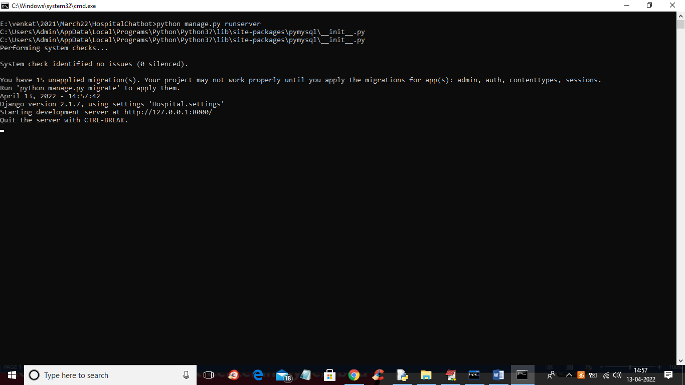

In above screen server started and now open browser and enter URL as <http://127.0.0.1:8000/index.html> and press enter key to get below output

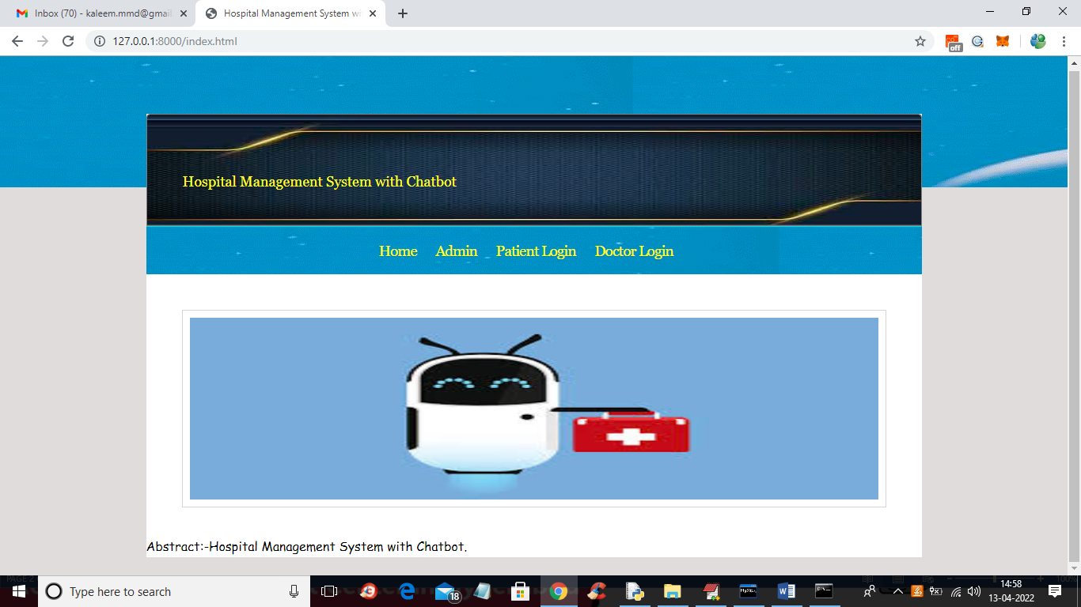

In above screen click on ‘Admin’ link to get below screen

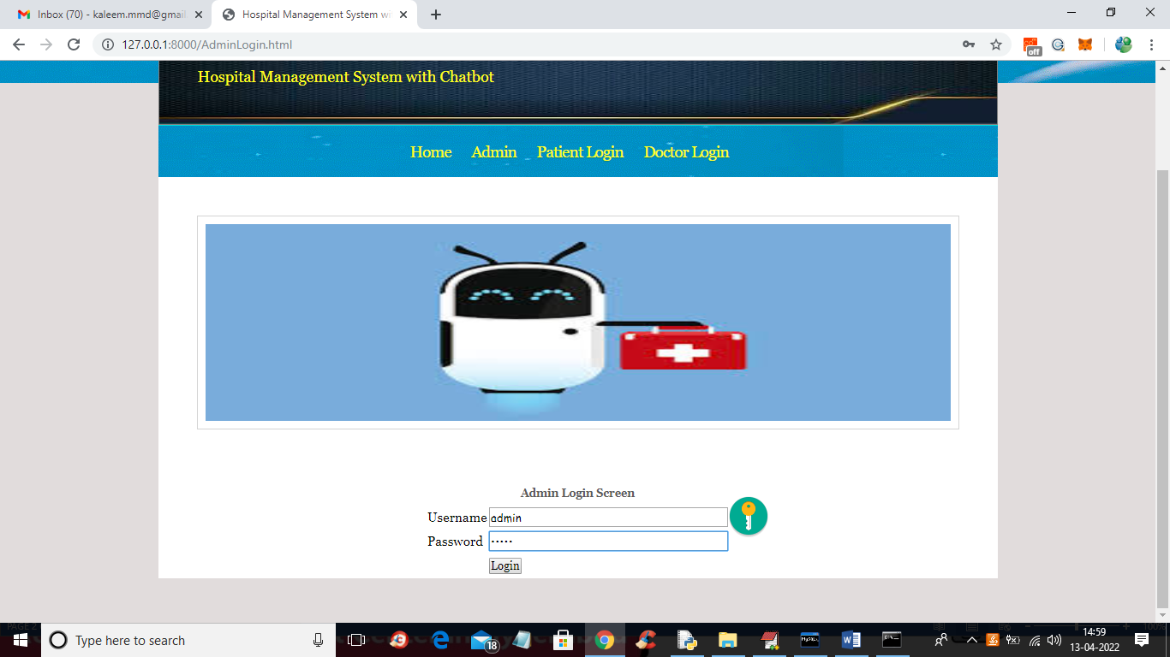

In above screen admin is login and after login will get below screen

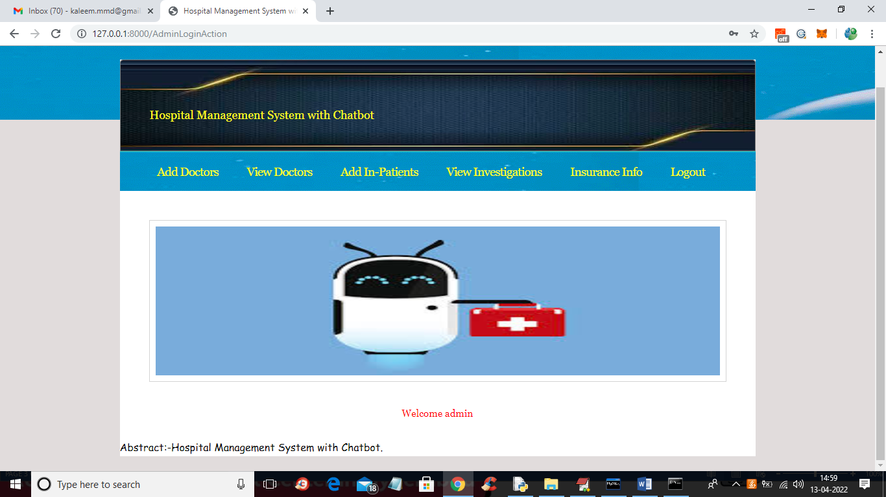

In above screen click on ‘Add Doctors’ link to add new doctor details

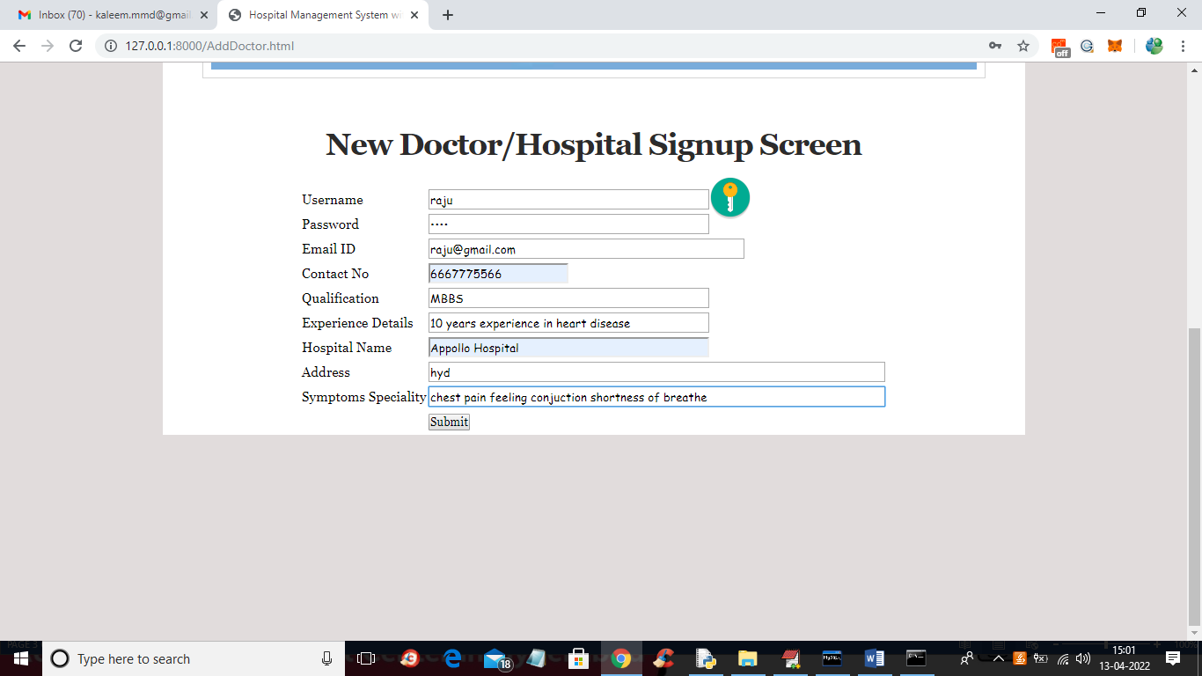

In above screen admin will ad doctor details and in last field admin will add doctor speciality separate with spaces so CHATBOT can match this with patient symptoms and suggest doctor and now press button to save details

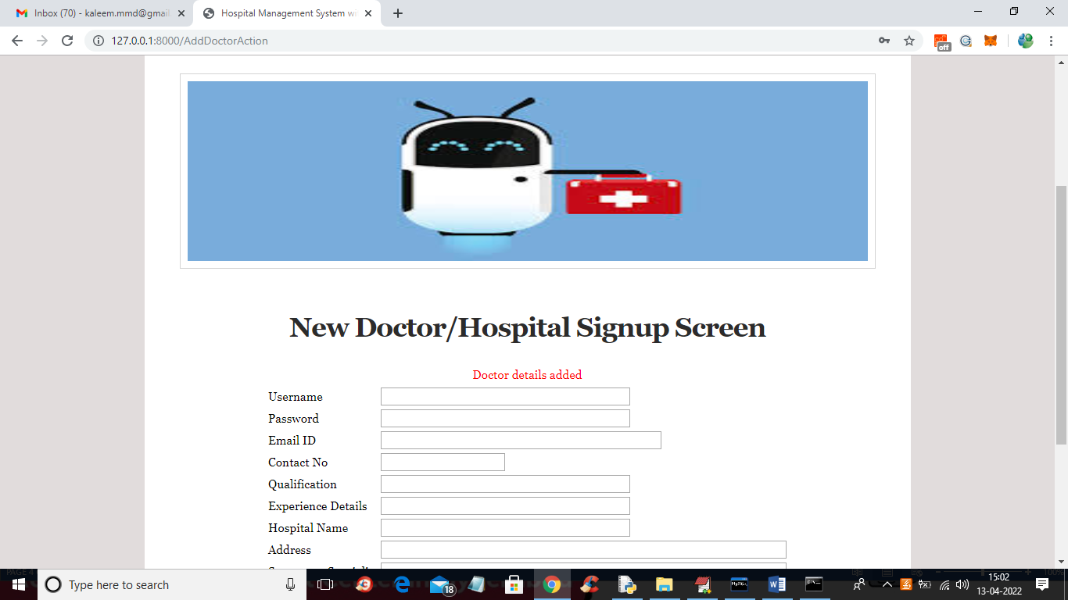

In above screen doctor details added and now click on ‘View doctors’ link to view all available doctors

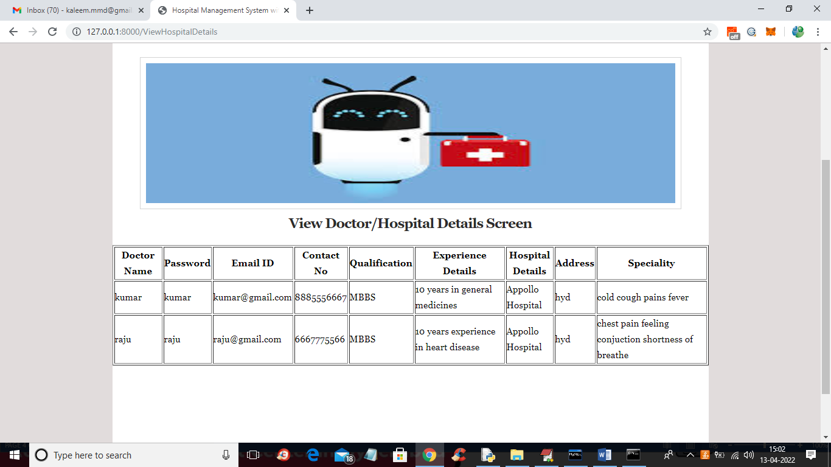

In above screen we can see all doctor details and now click on ‘Add In-Patients’ link to add patient details

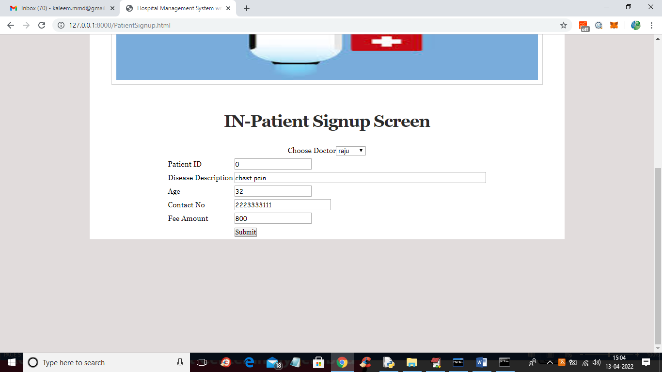

In above screen admin will select appropriate doctor for patient and then enter patient id as 0 if this patient is new so application will generate new ID and if old patient then you can enter existing patient ID and enter remaining details and press button to get below details

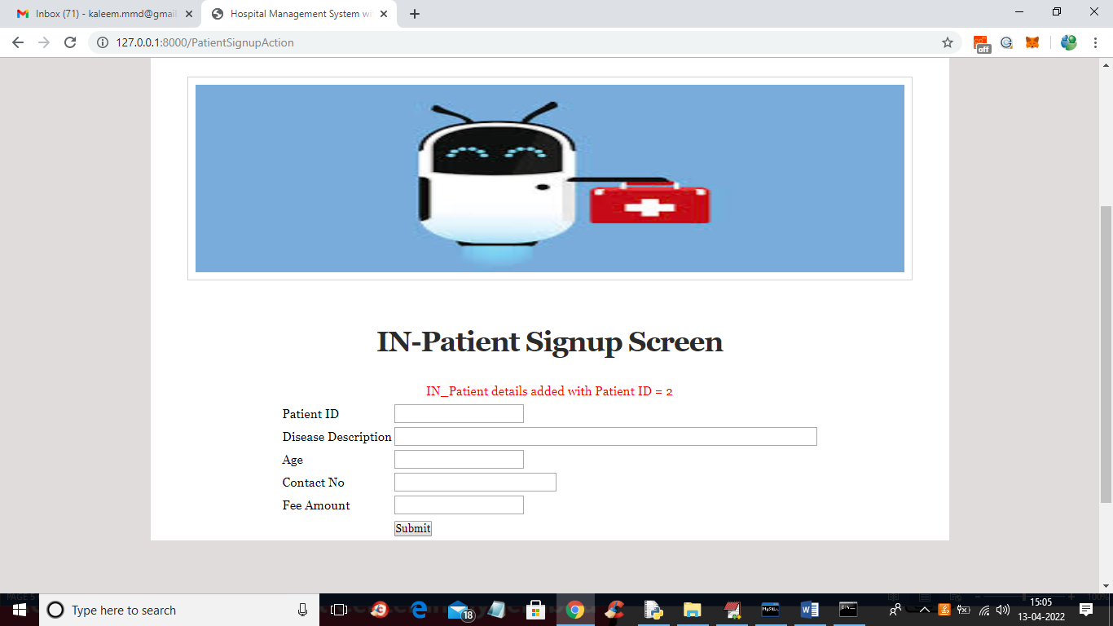

In above screen patient details added and generated ID is 2 and now click on ‘View Investigations’ link to view all patients details

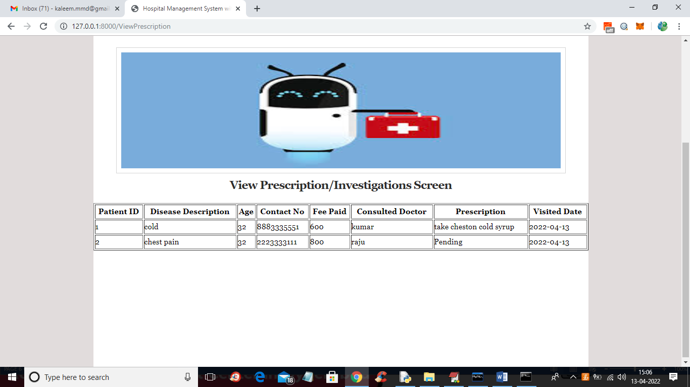

In above screen if doctor not given any prescription to any patient then it will display ‘Pending’ otherwise display the given prescription. Now click on “Insurance Info” link to view insurance details like below screen

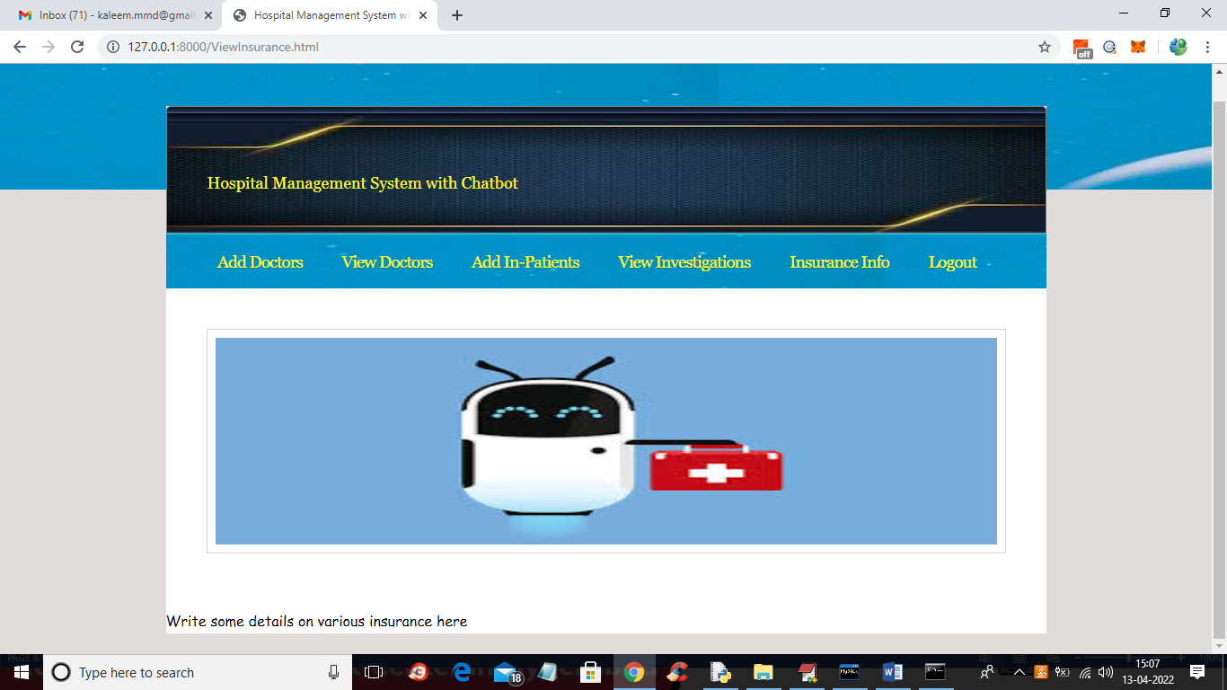

In above screen you need to write some insurance description so admin can explain to patients and now logout and login as patients

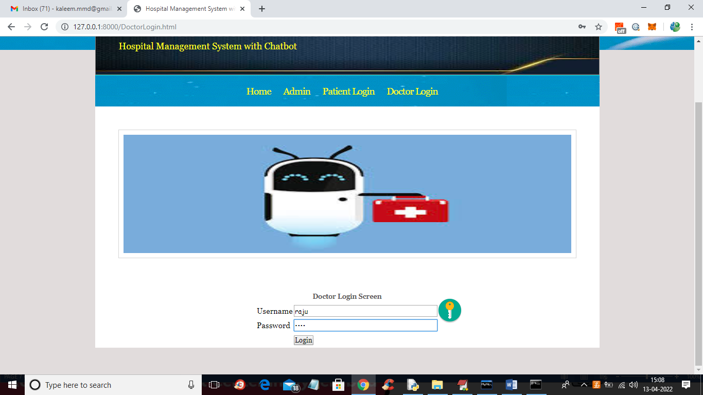

In above screen doctor is login and after login will get below screen

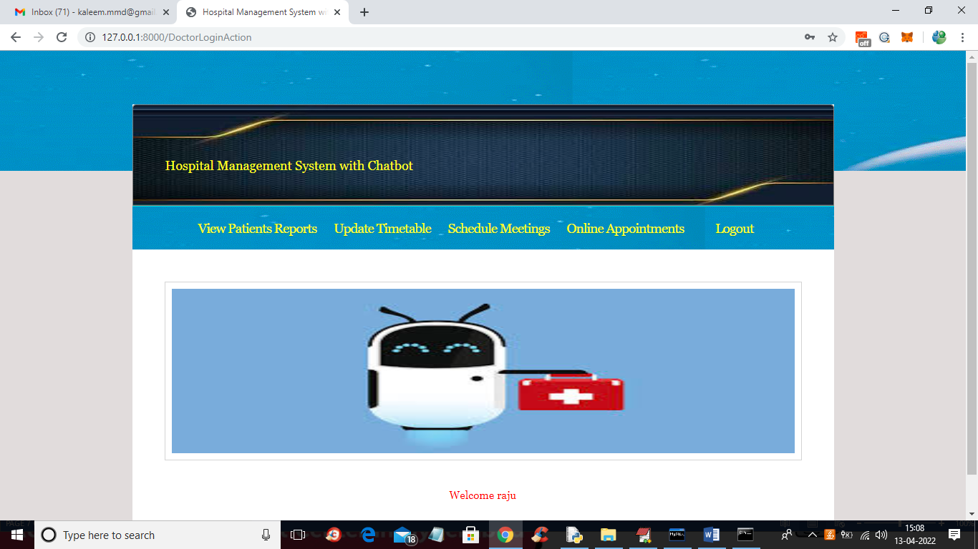

In above screen doctor can click on ‘View Patients Reports’ link to view In-Patient details and then generate prescription

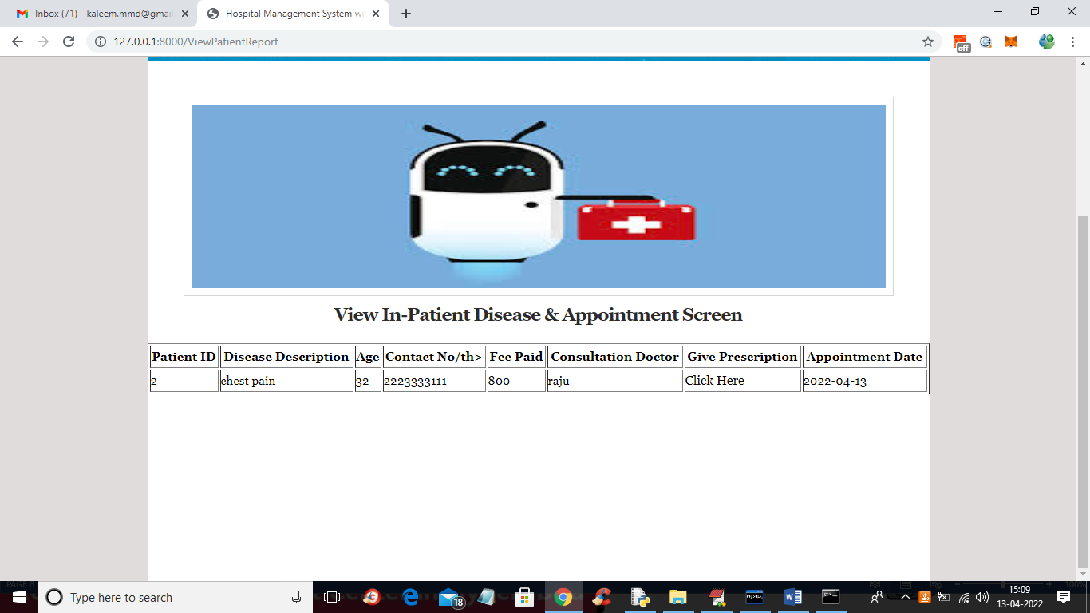

In above screen doctor can view all patient details and then click on ‘Click Here’ link to give prescription to patient

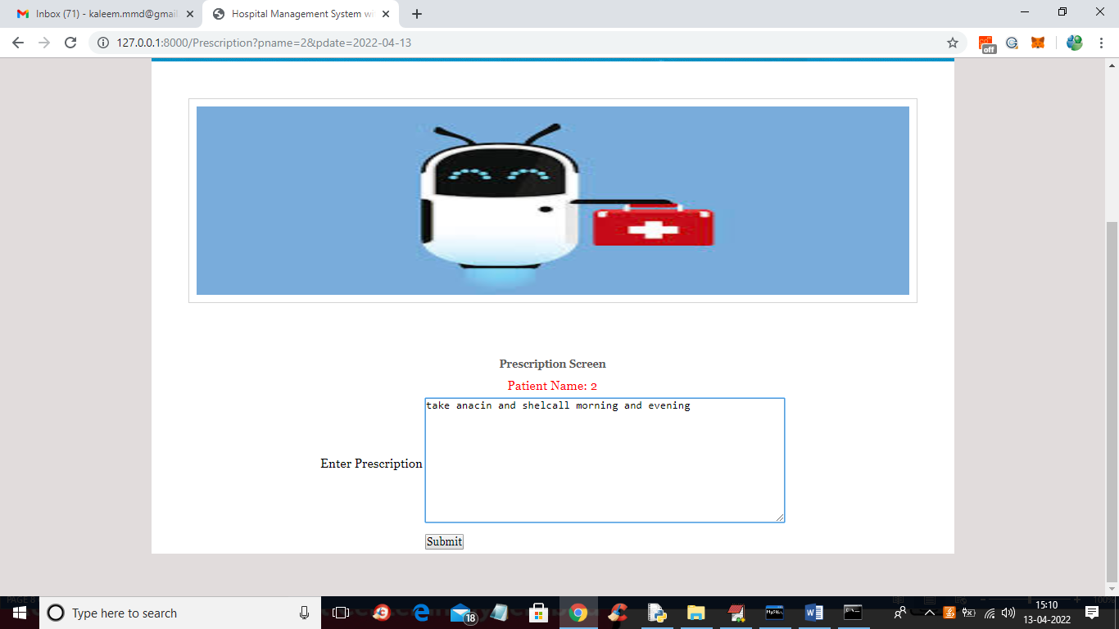

In above screen doctor is giving prescription to patient and press button to generate prescription like below screen

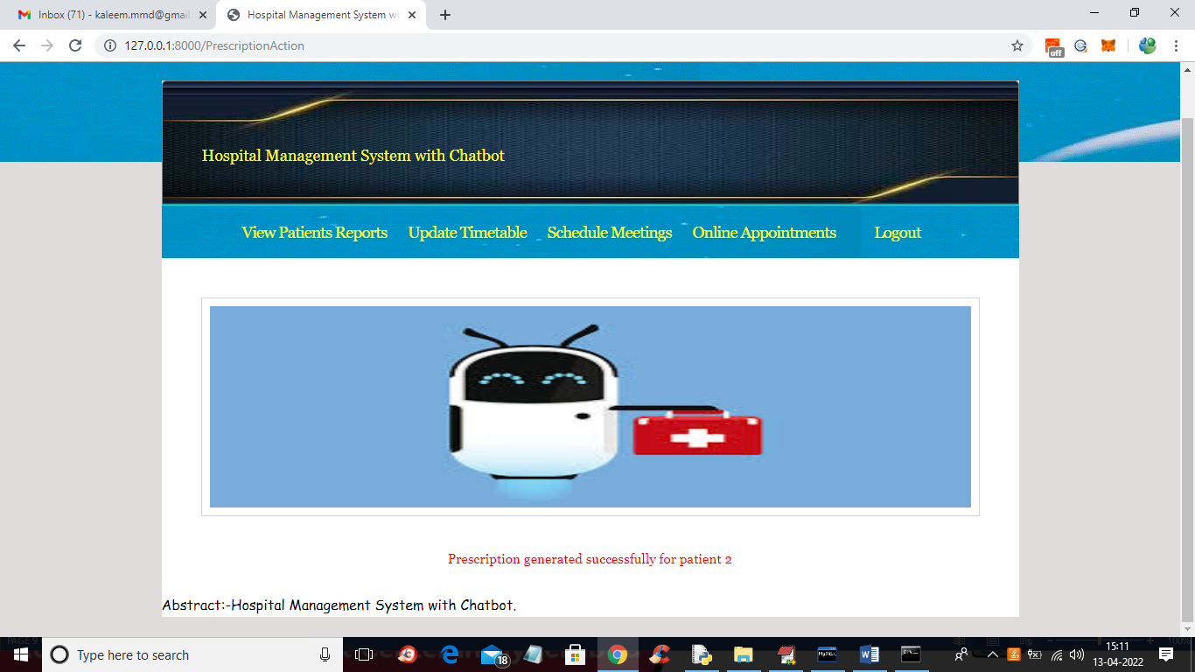

In above screen prescription generated and now click on ‘Update Time Table’ link to add time details

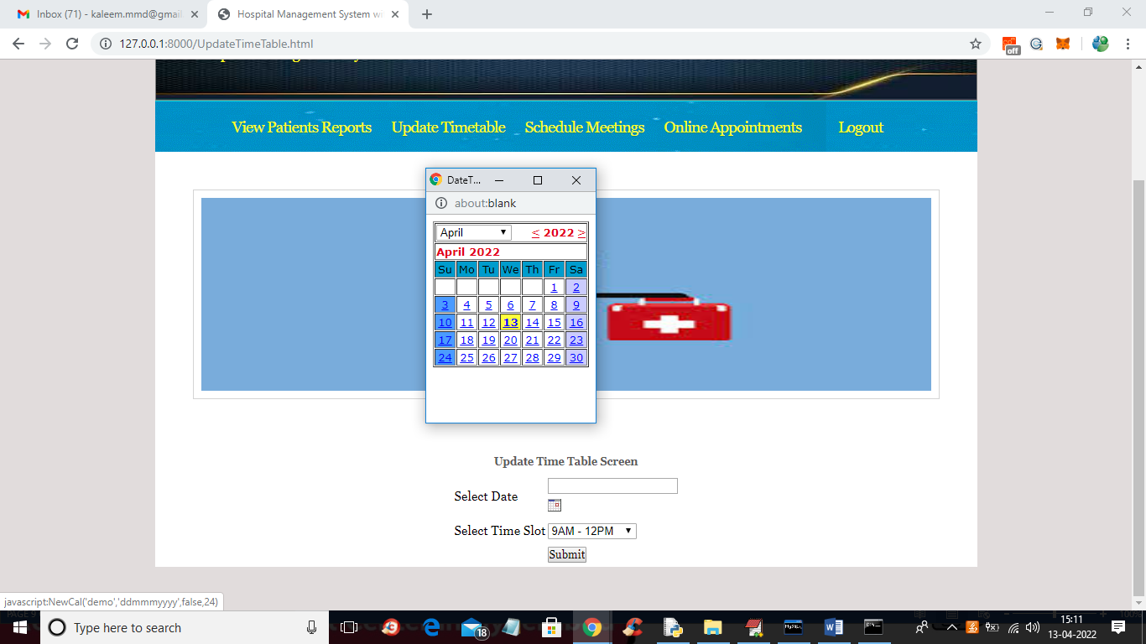

In above screen doctor will select date and then select time slot for time table and press button to update timing

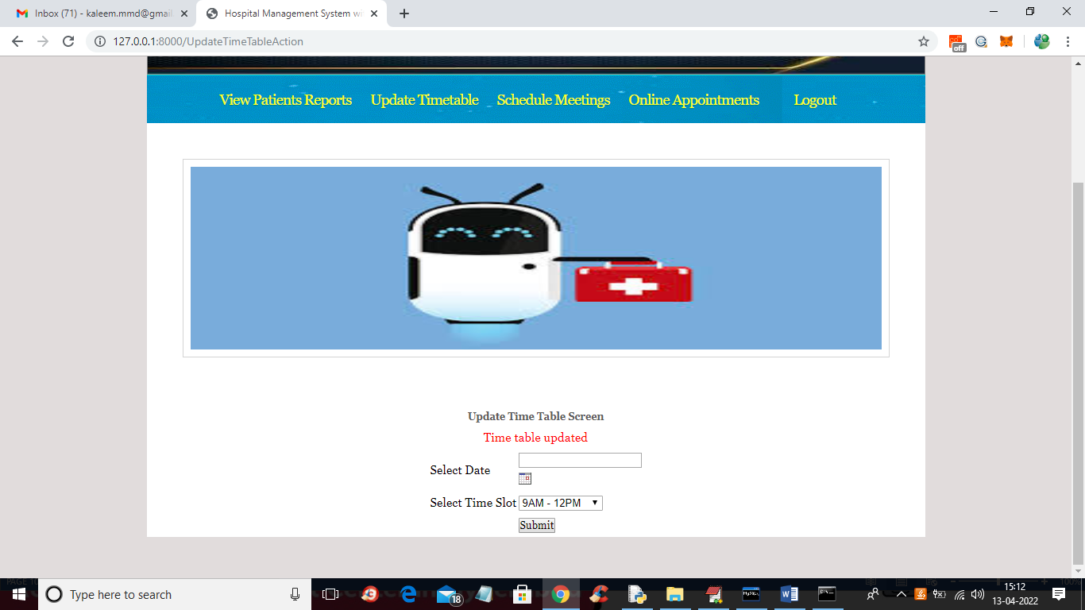

In above screen time table updated and similarly doctor can update meeting and online appointment timings and now logout and login as patient like below screen

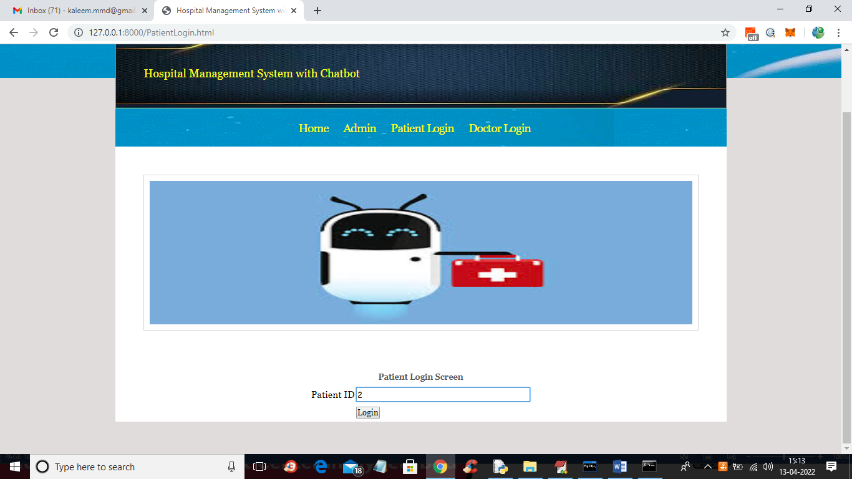

In above screen patient is login by entering his ID and press button to get below screen

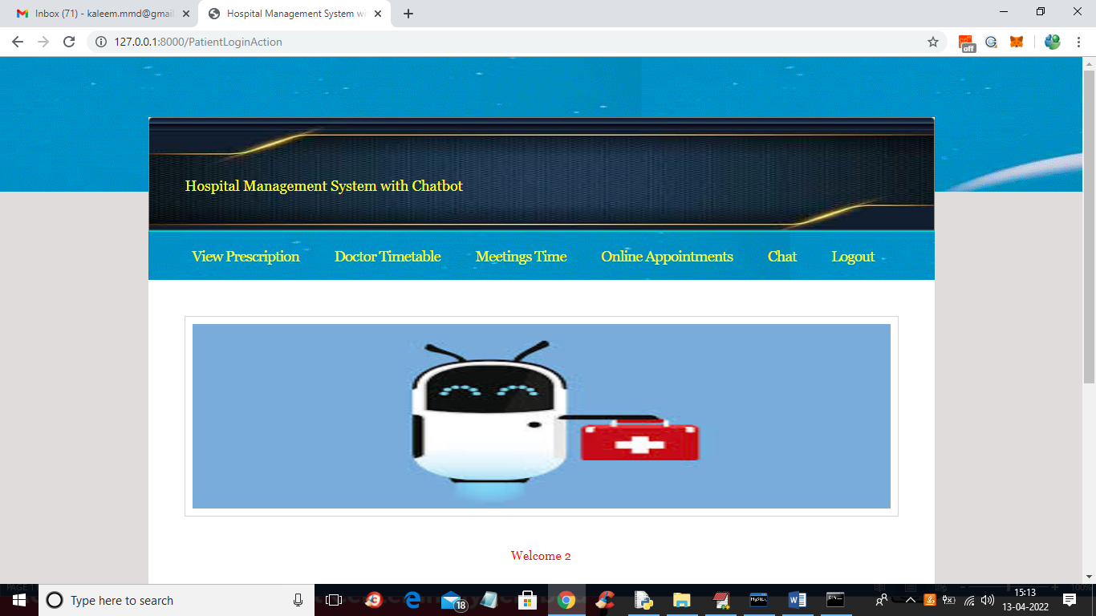

In above screen patient can click on ‘View Prescription’ link to view prescription given by doctor

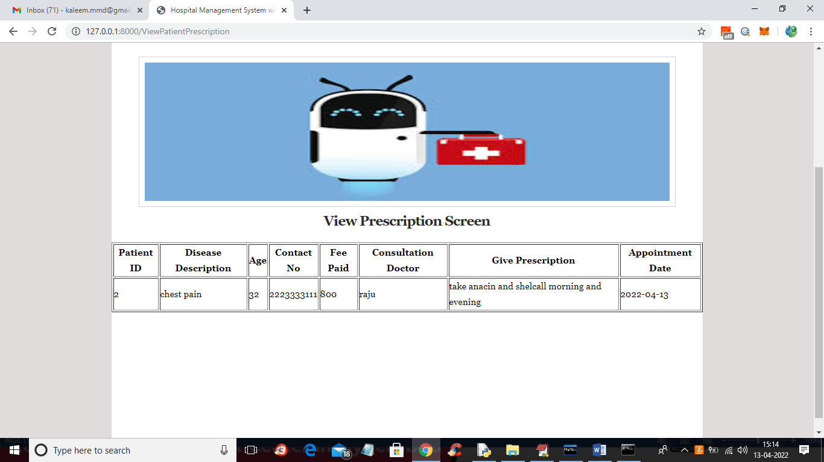

In above screen in prescription column patient can view the doctor’s prescription and now click on ‘View Time Table’ link to view all doctors available timing

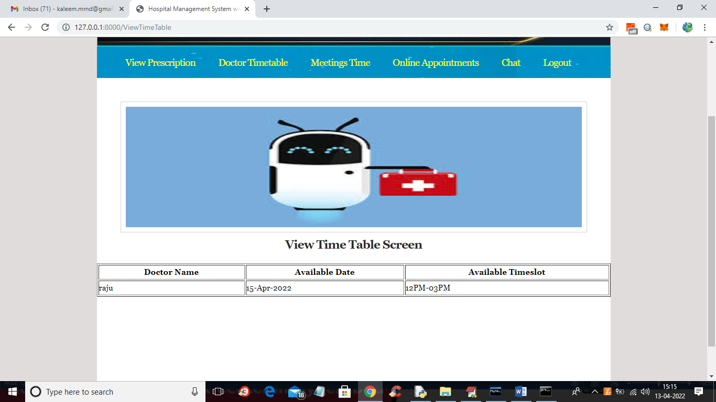

In above screen patient can view the doctor availability details and similarly patient can view meetings and online appointment timing and now click on ‘Chat’ link to get below screen

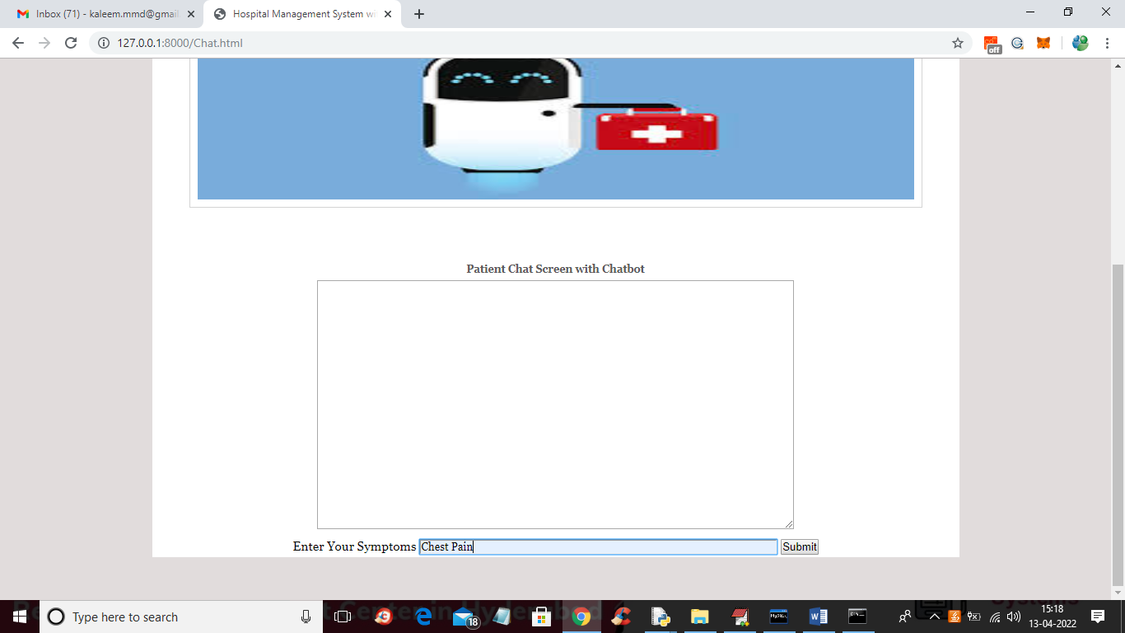

In above screen patient entered some symptoms and press button to get response from chatbot like below screen

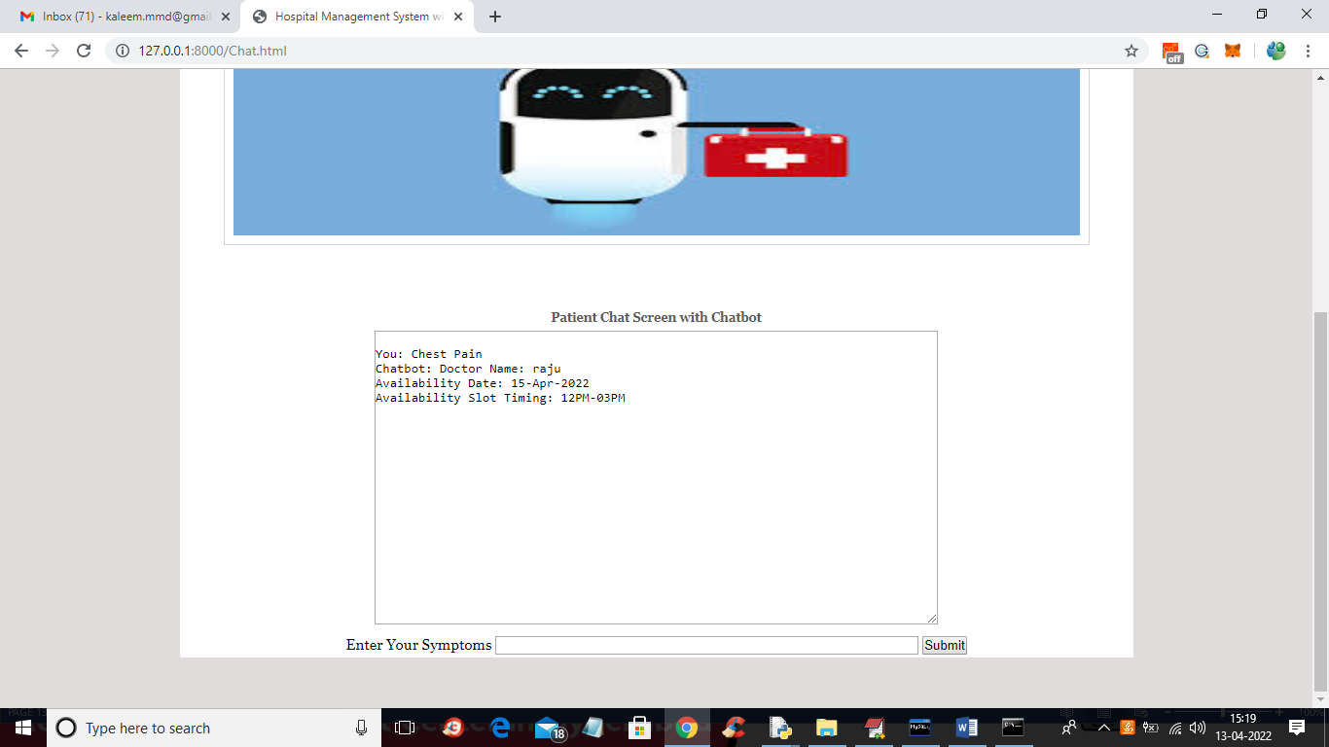

In above screen for given symptoms chatbot suggested doctor raju with date and time and now try another symptoms

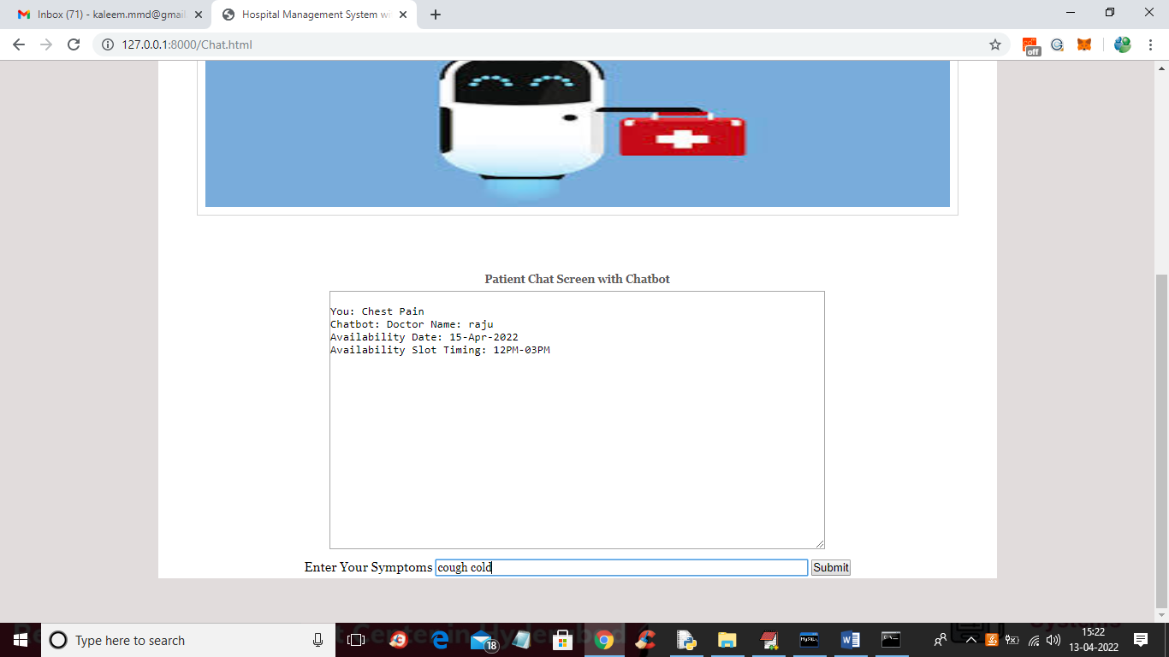

In above screen entered symptoms as cough and cold and below is the response

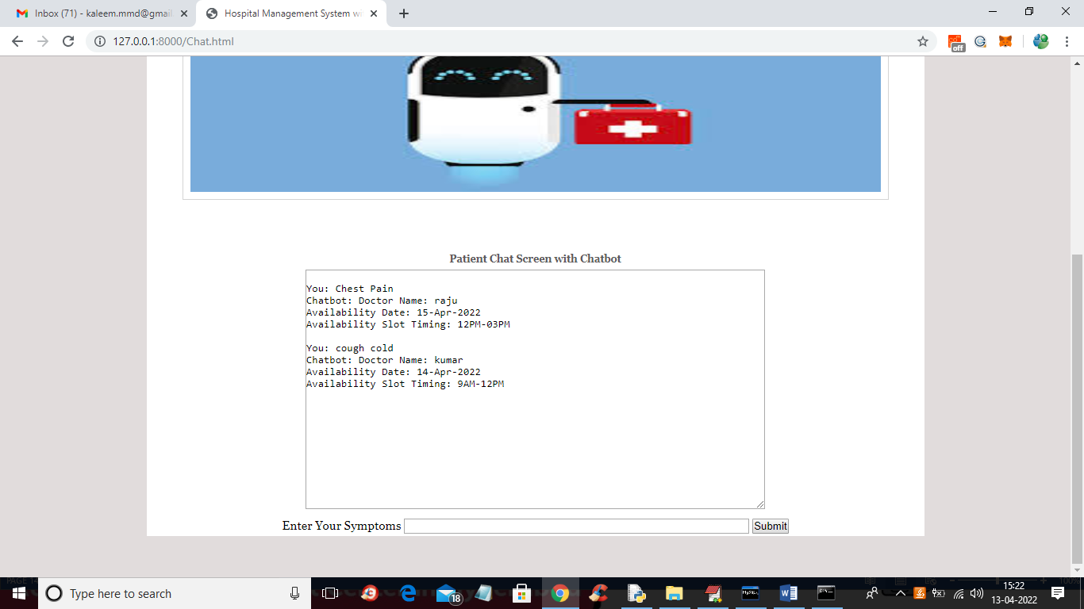

In above screen we got response from chatbot and if u give unrelated query then it will reply ‘Not Available’

Note: For each doctor add his time table so chatbot can suggest doctor and time to patients